302 - Flight - Radios, Navigation, Jettison

Radios -- WIP
COM1 | R-832M | VHF | 118.000 to 390.975 MHz?? | AM
- Pre-set channels only, no manual tuning
- On radio panels (left console, behind throttle):
  - SQUELCH switch ... ON
  - RADIO CONTROL switch ... ON
  - Change channel with cross-shaped knob.

Navigation
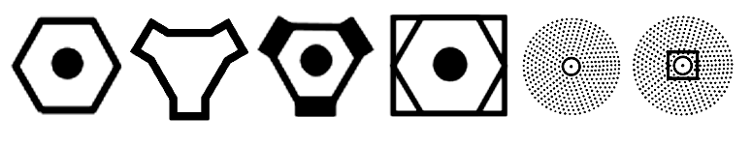 VOR TACAN VORTAC VOR-DME NDB NDB-DME
NDB with ADF receiver
- On radio panel (left console, behind throttle):
  - ADF switch ... ADF
  - Adjust volume as needed with knob.
- On RLK-41 control panel (right console forward, behind CB switches):
  - Tune Inner and Outer marker frequencies on the left and right dials respectively.
  - Set Mode knob to AUT or MAN. AUT will automatically switch from the Outer marker to the Inner marker, see below.
  - TLF/TLG switch ... As desired; TLF (telephone) puts the beacon audio to your headphones, TLG (telegraph) shows the beacon signal intensity on the control panel indicator.
  - Audio control switch ... As needed based on cockpit; L for front, R for rear.
- Outer/Inner NDB selector switch ... O (front left wall below gear handle)
- ADF gauge (instrument panel below VSI/slip indicator) points to beacon. Beacon is directly ahead when needle points up.
- When you fly over the Outer marker, MARKER caution light will illuminate. If Mode knob is set to AUT, and you are on course with gear down, ADF system will automatically switch to tracking the Inner marker. If Mode knob is set to MAN, you need to change the Outer/Inner NDB selector switch manually (front left wall below gear handle).
RSBN navigation (similar to VOR/TACAN)
 RSBN
- Not all airports have RSBN; it is not the same as TACAN or VOR.
- You may need to be at least 2500 m altitude to receive RSBN.
- RSBN Mode switch ... NAVIG (right console middle, behind RLK-41 control panel)
- Set RSBN channel with RSBN channel knob (right console middle)
  - AZIMUTH and DISTANCE lights should illuminate when it starts receiving.
- Set course as needed with knob on HSI compass.
- On HSI, thin white needle shows bearing to RSBN beacon, double-line white needle shows selected course. Distance is shown in readout below HSI. To get on course, fly on the other side of the thin needle from the double-line needle until needles match, then fly their heading. (e.g. If double-line needle is to right of thin needle, fly a direction to the left of the thin needle heading.) needs verification
RSBN+PMRG landing (similar to ILS)
- PMRG is military only, and will only be available at friendly coalition airports. It may also only be available for certain runways (as directed by airport traffic control) and in certain weather conditions (e.g. may not be available if there is good visibility or no wind).
- When you are 20 km from landing airport and 600 m altitude, change RSBN receiver to PMRG channel.
- SDU switch ... ON (right console, behind RLK-41 control panel)
- RSBN Mode switch ... LANDING (right console middle, behind RLK-41 control panel)
- T and K flags on artificial horizon should disappear.
- Artificial horizon will show localizer (horizontal) and glideslope (vertical) on small indicators at top and left. Lines show the approach path relative to your position, so chase the lines to get on path, as you would with ILS.

Jettison
- Drop tanks are empty when DROP TANKS caution light illuminates (right caution lights)
- Red guarded switches with bomb icons on front left wall, under weapon arming switches. Flip switches to jettison, left switch for outer pylons, right switch for inner pylons.
- Drop tanks will always be on the inner pylons.

